
RAMAIAH
Institute of Technology
USN | 1 | M | S

(Autonomous Institute, Affiliated to VTU)
(Approved by AICTE, New Delhi & Govt. of Karnataka) Accredited by NBA & NAAC with ‘A’ Grade

MAKE UP EXAMINATIONS – SEPTEMBER 2021
Program | : | B.E. : Common to all Programs | Semester | : | I / II
Course Name | : | Basics of Civil Engineering and Mechanics | Max. Marks | : | 100
Course Code | : | CV14/CV24/CV101/CV201 | Duration | : | 3 Hrs

Instructions to the Candidates:
- Answer one full question from each unit.
- Missing data can be assumed suitably.

 |  | UNIT- I
1. | a) | Briefly explain the role of civil engineers in infrastructure development of the country. | CO1 | (10)
 | b) | Explain the scopes of the following branches in civil Engineering:  - Structural Engineering  - Geotechnical Engineering. | CO1 | (10)
2. | a) | Discuss the effects of infrastructure facilities on the socio economic development of a country. | CO1 | (10)
 | b) | Mention the properties of the following:  - PSC ii) Steel | CO1 | (05)
 | c) | Differentiate between PCC and RCC. | CO1 | (05)
 |  | UNIT – II
3. | a) | Define: i) Force ii) Continuum iii) Rigid body iv) Moment of a couple. | CO2 | (10)
 | b) | Replace the 1000N force as shown in the Figure by two forces, a 500 N force acting in the negative Y direction and a force F which together are equivalent to the action of the 1000N force. Find the magnitude of F and the angle β that it makes with the Y axis.  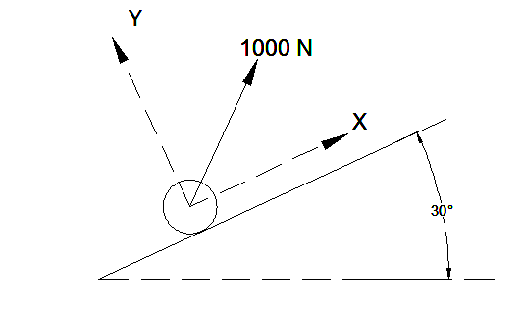 | CO2 | (10)
4. | a) | State and prove varignon’s theorem. | CO2 | (10)
 | b) | Determine the resultant of coplanar concurrent system show in the Fig.4 (b).  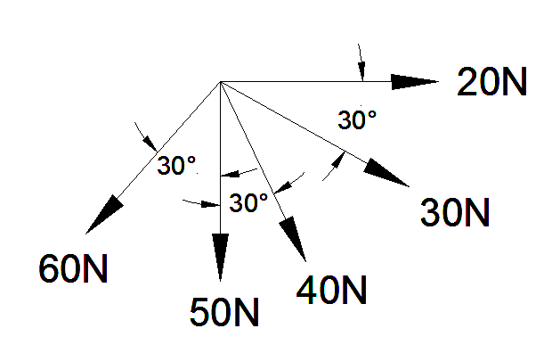  Fig.4(b) | CO2 | (10)
 |  | UNIT – III
5. | a) | List out different types of beam with various loading conditions. | CO3 | (10)
 | b) | Two identical rollers, each weighing 400 N, are placed in a trench as shown in Fig. Assuming that all contact surfaces are smooth, determine the reactions at contact points A, B, C, and D.  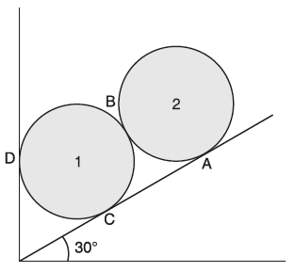 | CO3 | (10)
6. | a) | Determine the reactions at the supports for the system shown in Figure Consider the top beam CD.  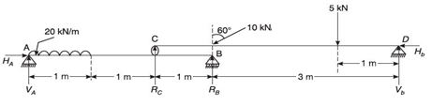 | CO3 | (10)
 | b) | Two spheres each of radius 100 mm and weight 5 kN are in a rectangular box as shown in Fig. Calculate the reactions at all the points of contact.  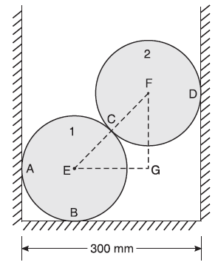 | CO3 | (10)
 |  | UNIT – IV
7. | a) | Derive an expression to determine centriod of Triangular laminar? | CO4 | (08)
 | b) | Determine the center of gravity of the shaded area of the lamina shown in Fig.7(b) about its centroidal X and Y axis?  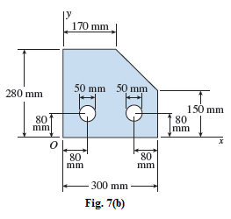 | CO4 | (12)
8. | a) | State and Prove Parallel axis theorem? | CO4 | (06)
 | b) | Determine the Moment of Inertia of the given composite section shown in Fig. 8(b) about its centroidal X axis?  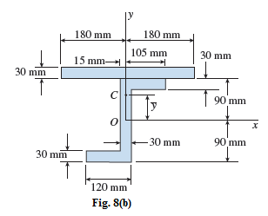 | CO4 | (14)
 |  | UNIT – V
9. | a) | Define Coefficient of friction. Also state the laws of static friction. | CO5 | (05)
 | b) | A uniform ladder 4 m long, weighs 200 N. It is placed against a wall, making an angle of 60⁰ (with the floor) as shown in Fig 9(b). The coefficient of friction between the wall and the ladder is 0.25 and that between the ground and the ladder is 0.35. The ladder in addition to its own weight, has to support a man of 1000 N at the top at B. Calculate:  - The horizontal force ‘P’ to be applied to the ladder at the ground level to prevent slipping.  - If the force ‘P’ is not applied, what should be the minimum inclination of the ladder with the horizontal, so that it does not slip with the man at the top?  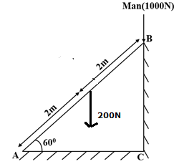  Fig. 9(b) | CO5 | (15)
10. | a) | Define the terms angle of repose and angle of friction with neat sketches and prove angle of repose is equal to angle of friction? | CO5 | (05)
 | b) | A projectile is fired from the top of cliff 150m height with an initial velocity of 180m/s at an angle of elevation of 300 to horizontal. Neglecting air resistance; Determine:  - The greatest elevation above the cliff  - The great elevation above the ground reached by the particle  - The horizontal distance from the gun to the point where the projectile strikes the ground. | CO5 | (15)

****************

